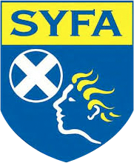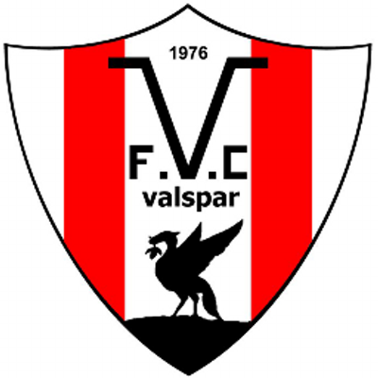

Introduction
SYFA Code of Conduct
Football is a fantastic game and it gives a great deal of fun and pleasure to players, club officials, parents and spectators alike.
We all have a responsibility to ‘Respect Our Game’ and follow the laws of the game to allow the game to be played properly, fairly and in a true sporting manner.
The SYFA, members and all involved have a responsibility to promote high standards of behaviour by providing a more enjoyable playing environment.
We invite leagues and clubs to promote the codes of conduct to help take a positive step towards improving behaviour on our touchlines and teaching young people to respect their team-mates, opponents, rules, officials, and themselves.
Our Roles and Responsibilities
Club Officials, coaches, parents, spectators, referees, volunteers and players all have a role in developing a positive football culture.
By involving the whole community, we inspire all, to set new standards and have a positive impact on their involvement with young people in football.
Working together we can encourage a cultural shift in football in Scotland to inspire young people to reach their potential in football and life.
We ALL have a responsibility to encourage all club officials, coaches, players, parents and spectators to follow the codes of conduct, to respect our game and deliver a consistent level of respect and sportsmanship for everyone involved in football.

PARENTS AND SPECTATOR CODE OF CONDUCT PARENTS AND SPECTATOR OBLIGATIONS TOWARDS THE GAME
• parents and spectators should adhere to the laws of the game, SYFA code of conduct, SYFA supplementary and playing rules, all SYFA protection policies, SYFA disciplinary procedures and all related SYFA policies and any amendments
• parents and spectators should remember that young players play football for fun
• parents and spectators should always applaud good play, effort and performance from both team’s players and not just results
• parents and spectators should always remain outside the field of play or within any designated spectators area
• parents and spectators should ensure that players obtain a sense of personal achievement have high self-esteem
• parents and spectators should ensure that players improve their skills and techniques
• parents and spectators should ensure that players have a positive attitude and show respect to other players, club officials, club coaches, match officials and other players and spectators
• parents and spectators should always be positive and encouraging towards all of the players not just their own and always respect the match officials’ decisions
• parents and spectators should develop an appropriate supportive relationship with both club officials and their son or daughter based on mutual trust and respect. Support the club’s decisions and discuss any concerns directly with the club
•parents and spectators must never engage in, or tolerate, offensive, insulting, or abusive language or behaviour
• parents and spectators must never coach any player during the game or confuse the players by telling them what to do
• parents and spectators must never shout and scream or criticise a player for making a mistake as mistakes are part of the development of a player
• parents and spectators MUST always encourage everyone participating in football

